Essay Plan Political Sociology 1 Class, Education, and Economic Inequalities
How do class, education, wealth and other economic inequalities aﬀect voting behaviour?

Over the past few decades political scientists have focused on the decline of the “class vote” in industrialized western democracies. With few exceptions, members of the working class (whether defined along income lines or, as many more fine-grained analyses take, focused on occupational position) seem to be voting less for the traditional parties of the left-wing, even though working-class identification seems to be holding constant across much of Europe. So how can we explain voting behavior today? Education has taken an increasingly central role, though its importance, and the way it is activated, varies within the different historical experiences and political opportunity structures of advanced industrialized democracies. Importantly, however, while education tends to push younger voters towards left-libertarian parties (and lack of education pushing other young voters towards anti-populist parties) education remains, relative to the heyday of the class vote, a relatively weak predictor for election choices and seems to have left. The increasing importance and prevalence of education among younger cohorts also interacts with the supply-side; that is, the options that parties present to voters – and with long-term structural changes in the workforce and the economy, as explored by Kitschelt (1994) or by more controversial studies like those of Beck (1992).
Various theorists have asserted that class and other explicit economic inequalities have weakened their previously strong link with voting behavior. There are various theoretical explanations for the disappearance of the class vote. Beck’s individualization thesis was especially influential; it argued, that while class inequality themselves remain relatively concrete, peoples’ experience of these inequalities have changed, as education, increased labor market mobility, and increasing competition all drive individualization and demobilize class identities.
Beck’s account is more expansive then Kitschelt, Lange, Stephens, and Marks’s (1999) account of transformations within advanced industrial states; Kitschelt makes a more limited claim that the shrinking of the industrial working class and an interlocked series of economic crises put pressure on social democratic parties to shift their appeal to the middle class. This is because Beck has his eyes on a grand theory of postmodernism; Kitschelt really only hopes to explain recent shifts in capitalist states (or recent as of the 90s!)
While Beck’s account has come under fire (Heath, Curtice, and Elgenius 2009), it offers some important insights to explaining the relationship between economic inequalities and political behavior. The criticism cited above takes Beck to account for supposedly failing to recognize that class identity, and salience of class identity, have not completely disappeared; but they do find that in both the case of working class identification and salience that it has dipped in the past 30 or so years in Britain. They place most of the blame on supply-side changes in party rhetoric.

Sectoral changes are recognized across the field with near unaniminity in playing a large part in changes in political behavior, and in the rising importance of education as a predictor of voting behavior. Across all advanced industrialized democracies manufacturing as a share of employment has been in secular decline in most cases since at least the 1960s. A concurrent rise has been observed in the number of people working in service sectors (who generally, though not universally, exhibit similar behavioral attitude to those from manufacturing sectors – see graph 3 labeled below, from Abou-Chadi, Hix 2021), and, more importantly for any thesis about the new role of education in voting patterns, a large increase in “the middle class” – those with occupations dependent on a university degree, which are now often the single largest demographic in many western democracies.

Finally one of the most important changes which has played a role in decreasing the class vote and in increasing educational inequalities in the vote is changes in the supply-side; most importantly, changes in party appeals (which are difficult to measure quantitatively, though qualitative analyses generally agree in shifts in rhetoric across a number of social democratic parties) and new parties which have catered to and helped to cement emerging cleavages among younger cohorts. In both the United States and in the United Kingdom, party elites within the Labour Party and the Democratic Party began to distance themselves from previous working class constituencies in an attempt to appeal to better-educated professional and middle-class constituencies, under both the Blair and Clinton administrations. It is notable that these changes in supply seemed to have immediate and large-scale effects on at least UK understandings of the connection between occupation, class, and partisanship; under the shifts in labour in 1992 and 1997 one also sees a huge jump up in self-identified members fthe middle class identifying themselves with Labour, doubling from 17 percent to 32 percent among those who identified themselves as middle class without prompting and from 13 to 26 to those who identified themselves as middle class with prompting; while jumps in labour identification among self-identified members of the working class only jumped a few points at the same time.

The net effect of these significant changes varies across the United States, the UK, and Western European countries. Across western Europe, the growing importance of education, which is limited to younger cohorts, has created a “second dimension of politics” – which appears in terms of voting behavior relatively impervious or at least somewhat distant from the traditional “first dimension” which structures voting among older voters. Abou-Chadi and Hix (2021) identified that the first dimension – whereby wealthier and more educated voters have a higher propensity to vote for mainstream right parties – and older and less educated voters, members of or former members of traditional working class jobs – still continue to vote for traditional social democratic parties. But as this cohort has fallen off the scene, social democratic parties have given way to new left/libertarian and green parties, which have captured younger, educated voters, and far-right populist parties, which have captured less-educated voters. Exceptions exist to this pattern, as Gethin, Martínez-Toledano, and Piketty (2022) have identified; Portugal and Ireland, where partisan divisions over immigration have remained low and where industrialization was late and democracy’s reintroduction recent. In these countries, and in Scandinavia, working-class identity continues to be important in determining support for traditional-left wing parties, even for younger cohorts.
In the United Kingdom and the United States, FPTP systems have meant that the rising importance of education have had different effects. In the US, a long-term, though fluctuating dealignment has been observed. While occupational data is more limited, the graph below, based on income and attainment of a bachelor’s degree, is helpful in understanding these shifts: since the 1990s, and especially since 2012, the Democratic Party has become a party dominated by the better educated and higher earning. While previously this drift towards the higher earning as the base of democratic support fell off near the highest income brackets, the Democratic Party has now begun to attract even those voters who make more then 250,000 dollars, while the Republican party, while still struggling to attract the poorest voters (who still lean Democratic, though narrowly) they have begun to attract more and more “working-class” voters in middle income brackets without degrees. But the US also retains, without much change, one of the long-term trends in the behavior of its working class; low political participation, which coincides with a low prevalence of self-identification with the working class.

The UK exhibits possibly the most complicated pattern, in some ways somewhere in between the United States and the Europe pattern. Labor has hemorraghed support among the “white working class”> Education is now a strong predictor for Labour vote. It has also seen the political demobilization of the working class; Evans and Tilley claim that this is due to the shift in both the Labour and Conservative parties towards appealing to the growing middle class- the consequences of this demobilization are significant, including decreasing working class representation but also, recently, a shift in members of the white working class to the support of reform; reform increasingly resembles a part y of the traditional British working class. Thus class politics find their expression largely either in demobilization or increased support in far-right parties.

One important aspect here is that education, while traditionally a strong divide between the working and middle class, now no longer serves as such a good divider. One of the reasons why working class identitication has remained so high in Britain even as the size of the working class itself (in sectoral terms) has shrunk is because now many with advanced degrees believe themselves to be members of the working class. So while Evans and Tilley claim that a vote like Brexit reveals stark class divides, it may not be best to see class divides around cosmopolitanism simply hiding under a constrained party landscape (which since their publication has been less constrained as Reform has leapt into the mainstream) – firstly because of the complex relationship between class and education and because education is a significantly stronger predictor of Brexit vote then income.

This essay has unpacked some of the changing dynamics around how both occupational class and education are linked to voting behavior in western industrial democracies. It surveyed some of the major literatures and theories and offered an account of how education has restructured younger cohort’s voting behavior. It has also offered a brief account of how this change in voting behavior, accompanied by sectoral shifts, supply-side shifts in parties, and electoral systems, have seen concrete results in advanced industrialized democracies.

Works cited: 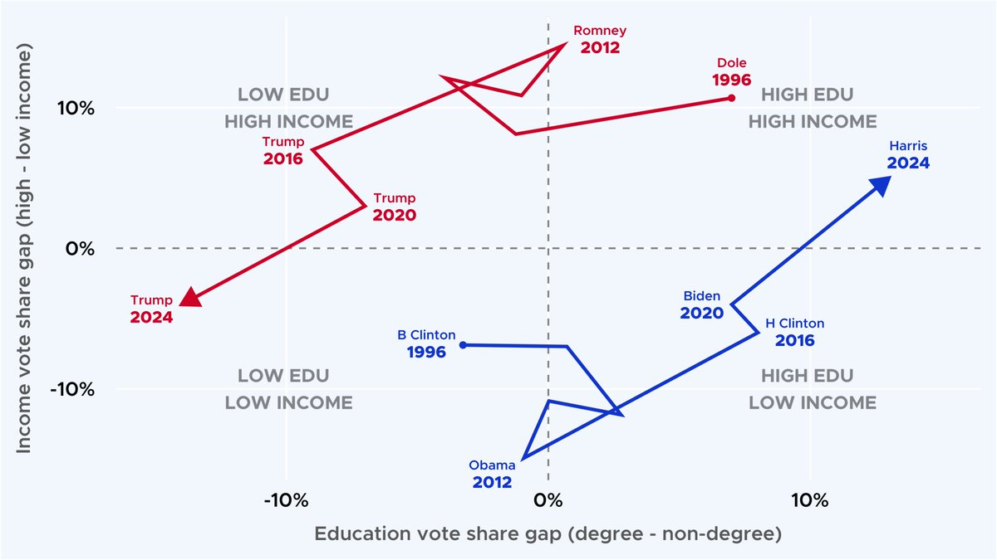

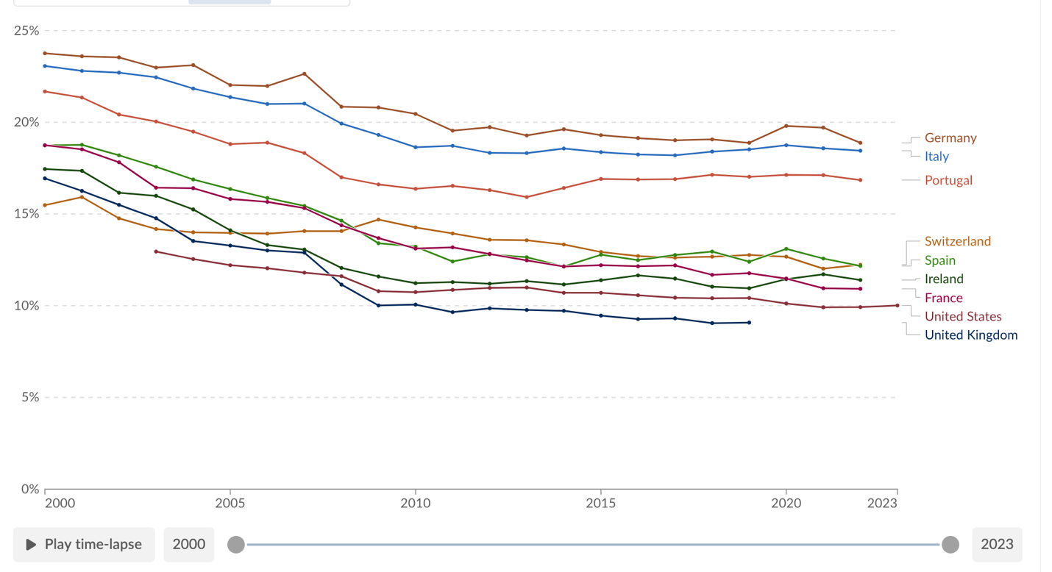
Graph 1: Manufacturing as a share of employment across some advanced industrialized democracies over the last 23 years
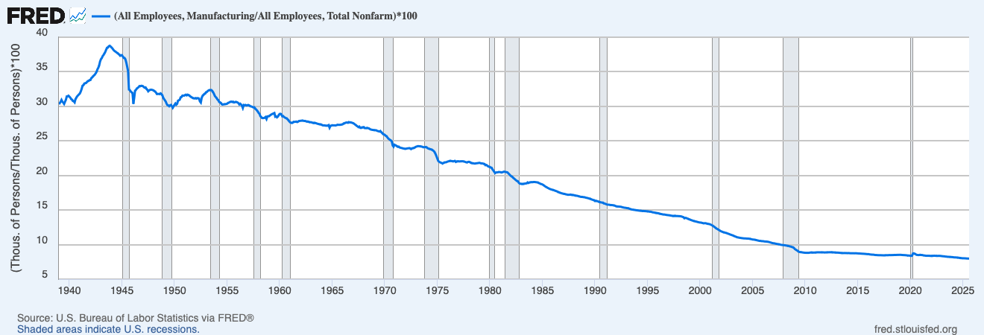
Manufacturing as a share of employment since 1940 in the United States
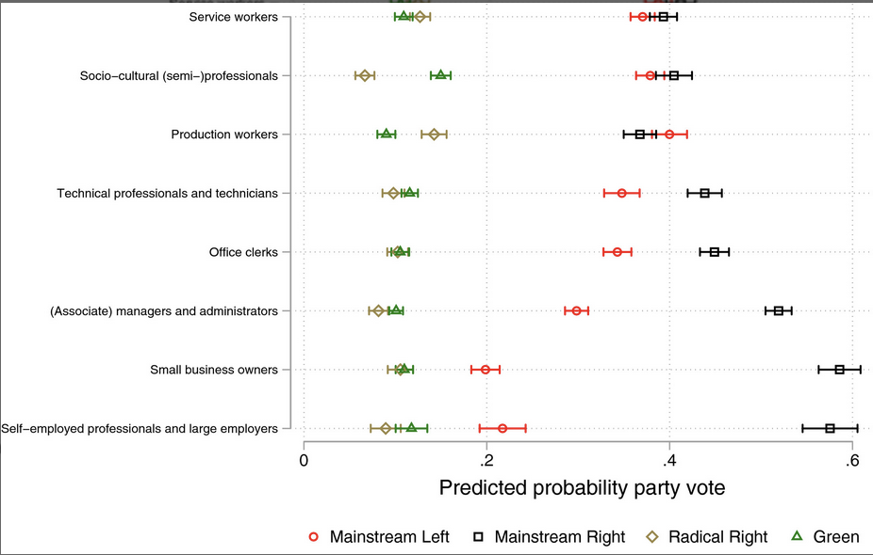
Predicted probability of voting for a party split into different occupational groups for 11 western European countries.

Abou-Chadi, Tarik, and Simon Hix. 2021. “Brahmin Left versus Merchant Right? Education, Class, Multiparty Competition, and Redistribution in Western Europe.” The British Journal of Sociology 72(1): 79–92. doi:10.1111/1468-4446.12834.
Ares, Macarena. 2020. “Changing Classes, Changing Preferences: How Social Class Mobility Affects Economic Preferences.” West European Politics 43(6): 1211–37. doi:10.1080/01402382.2019.1644575.
“Changing Classes, Changing Preferences: How Social Class Mobility Affects Economic Preferences: West European Politics: Vol 43 , No 6 - Get Access.” https://www.tandfonline.com/doi/full/10.1080/01402382.2019.1644575 (October 17, 2025).
Evans, Geoffrey, Rune Stubager, and Peter Egge Langsæther. 2022. “The Conditional Politics of Class Identity: Class Origins, Identity and Political Attitudes in Comparative Perspective.” West European Politics 45(6): 1178–1205. doi:10.1080/01402382.2022.2039980.
Evans, Geoffrey, and James Tilley. 2017a. “Conclusion.” In The New Politics of Class: The Political Exclusion of the British Working Class, eds. Geoffrey Evans and James Tilley. Oxford University Press, 0. doi:10.1093/acprof:oso/9780198755753.003.0009.
Evans, Geoffrey, and James Tilley. 2017b. “Identity.” In The New Politics of Class: The Political Exclusion of the British Working Class, eds. Geoffrey Evans and James Tilley. Oxford University Press, 0. doi:10.1093/acprof:oso/9780198755753.003.0003.
Evans, Geoffrey, and James Tilley. 2017c. “Introduction.” In The New Politics of Class: The Political Exclusion of the British Working Class, eds. Geoffrey Evans and James Tilley. Oxford University Press, 0. doi:10.1093/acprof:oso/9780198755753.003.0001.
Evans, Geoffrey, and James Tilley. 2017d. “Postscript: Brexit as an Expression of the ‘Democratic Class Struggle.’” In The New Politics of Class: The Political Exclusion of the British Working Class, eds. Geoffrey Evans and James Tilley. Oxford University Press, 0. doi:10.1093/acprof:oso/9780198755753.003.0010.
Gethin, Amory, Clara Martínez-Toledano, and Thomas Piketty. 2022. “Brahmin Left Versus Merchant Right: Changing Political Cleavages in 21 Western Democracies, 1948–2020*.” The Quarterly Journal of Economics 137(1): 1–48. doi:10.1093/qje/qjab036.
Goldberg, Andreas C. 2020. “The Evolution of Cleavage Voting in Four Western Countries: Structural, Behavioural or Political Dealignment?” European Journal of Political Research 59(1): 68–90. doi:10.1111/1475-6765.12336.
Grant, Zack, and Geoffrey Evans. 2024. “A New Dilemma of Social Democracy? The British Labour Party, the White Working Class and Ethnic Minority Representation.” British Journal of Political Science 54(3): 793–815. doi:10.1017/S0007123423000601.
Heath, Anthony, John Curtice, and Gabriella Elgenius. 2009. “Individualization and the Decline of Class Identity.” In Identity in the 21st Century, ed. Margaret Wetherell. London: Palgrave Macmillan UK, 21–40. doi:10.1057/9780230245662_2.
Jansen, Giedo, Geoffrey Evans, and Nan Dirk de Graaf. 2013. “Class Voting and Left–Right Party Positions: A Comparative Study of 15 Western Democracies, 1960–2005.” Social Science Research 42(2): 376–400. doi:10.1016/j.ssresearch.2012.09.007.
Kitschelt, Herbert. 1999. “European Social Democracy between Political Economy and Electoral Competition.” In Continuity and Change in Contemporary Capitalism, Cambridge Studies in Comparative Politics, eds. Herbert Kitschelt, Peter Lange, Gary Marks, and John D. Stephens. Cambridge: Cambridge University Press, 317–45. doi:10.1017/CBO9781139175050.013.
Lindh, Arvid, and Leslie McCall. 2020. “Class Position and Political Opinion in Rich Democracies.” Annual Review of Sociology 46(Volume 46, 2020): 419–41. doi:10.1146/annurev-soc-121919-054609.
Robison, Joshua, Rune Stubager, Mads Thau, and James Tilley. 2021. “Does Class-Based Campaigning Work? How Working Class Appeals Attract and Polarize Voters.” Comparative Political Studies 54(5): 723–52. doi:10.1177/0010414020957684.
Zacher, Sam. 2024a. “Polarization of the Rich: The New Democratic Allegiance of Affluent Americans and the Politics of Redistribution.” Perspectives on Politics 22(2): 338–56. doi:10.1017/S1537592722003310.
Zacher, Sam. 2024b. “Polarization of the Rich: The New Democratic Allegiance of Affluent Americans and the Politics of Redistribution.” Perspectives on Politics 22(2): 338–56. doi:10.1017/S1537592722003310.

